**High Level Design of Normal Traffic Flow**

|  |  |
| --- | --- |
| Author | Nisha N |
| Version | 1.0 |
| Status | Approved |
| Reviewer | Sohan, Rakshitha |

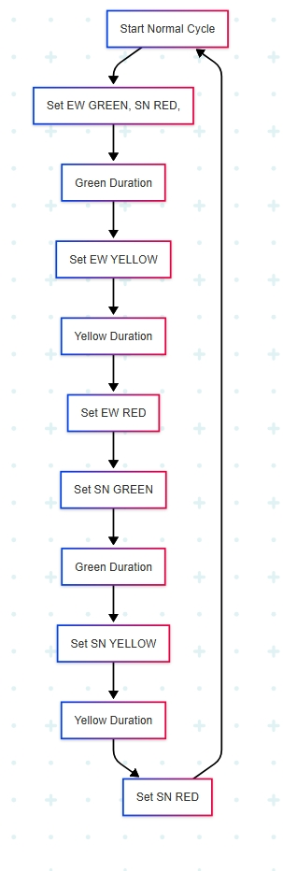**Normal traffic light flow description:**  
This flowchart represents a standard traffic light control cycle for an intersection between East-West (EW) and South-North (SN) directions.

Fig 1: Normal Traffic Flow

1. Start Normal Cycle
   * The system begins the normal operation cycle for traffic light control.
2. Set EW GREEN, SN RED
   * East-West direction is given the green signal.
   * South-North direction is held at red to stop traffic.
3. Green Duration
   * EW green light remains active for a specified duration, allowing vehicles to pass.
4. Set EW YELLOW
   * East-West green is turned yellow, warning drivers to prepare to stop.
5. Yellow Duration
   * A short delay allows vehicles already in the intersection to clear it safely.
6. Set EW RED
   * East-West signal turns red, stopping traffic flow in that direction.
7. Set SN GREEN
   * South-North direction is now given the green light to proceed.
8. Green Duration
   * SN green light remains on for a set time for vehicles to pass.
9. Set SN YELLOW
   * South-North green changes to yellow, indicating caution and preparing to stop.

10. Yellow Duration

* Allows clearing of vehicles already in the intersection.

11. Set SN RED

* South-North light is turned red, stopping traffic.

12. Loop Back to Start Normal Cycle

* The cycle restarts, continuously managing traffic between EW and SN directions.